Template for ICSOBA 2026 – Abstracts and Papers

Xxxx1, Yyyy2 and Zzzz3
1. Position of Xxxx
2. Position Yyyyy
Affiliation of Xxxx and Yyyy (if from the same company), City, Country
3. Position of Zzzz
Affiliation of Zzzz, City, Country
Corresponding author: abc@xyz.com
https://doi.org/10.71659/icsoba2026-xxYYY

Abstract

Text here……….

Keywords: Keyword1, Keyword 2, Keyword 3, Keyword 4, Keyword 5.

Section Title

Text here……….

Sub-Section Title

Text here……….

Sub-Section Title

Text here……….

    - Sub-Section Level 2 Title

Text here……….

    - Section Title

Text here ……….

Table Example

Table 1. Thermal conductivity and electrical resistivity of different ramming pastes [3].
Type of paste | A | B | C | D | E
Thermal conductivity at 1 000 °C (W/m⸳K) | 11.9 | 13.1 | 13.9 | 16.2 | 13.9
Electrical resistivity at 1 000 °C  (µW⸳m) | 67 | 52 | 48 | 36 | 37

Figure Examples

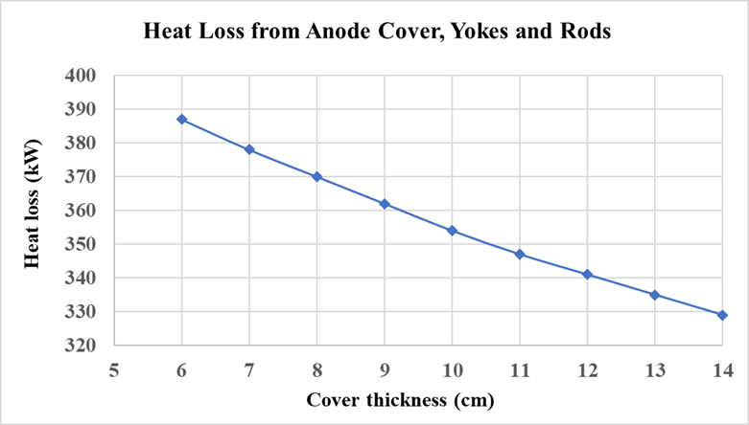
Figure 1. Heat loss from anode cover, yokes and rods [2].

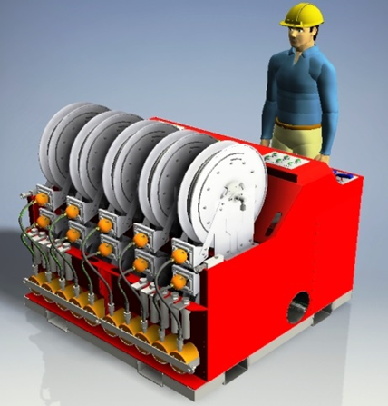 | 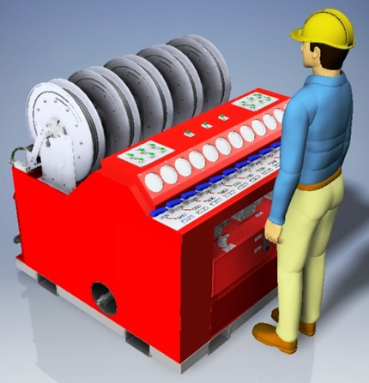
Figure 6. New hydraulic wedge puller. Left: back view, Right: front view.

Equation Example

Text here… Example – The Newton’s second law is governed by the following formula:

(1)
where:
F Force, N
m Mass, kg
a Acceleration, m/s²

Conclusions

References

- M. Sørlie and H. A. Øye, Cathodes in aluminium electrolysis, 3rd ed., Dusseldorf, Germany: Aluminium-Verlag, 2010.
- J. Tessier, “Multivariate statistical analysis of Hall–Héroult reduction cells: investigation and monitoring of factors affecting performance,” PhD Thesis, Laval University, Québec, Canada, 2010.
- A. A. Zarouni et al., “Energy and mass balance in DX+ cells during amperage increase,” Proc. 31st Int. Conf. ICSOBA and 19th Int. Conf. Aluminium Siberia, Krasnoyarsk, Russia, 4–6 Sept. 2013, TRAVAUX 42, pp. 494–499.
- W. Haupin and H. Kvande, “Thermodynamics of electrochemical reduction of alumina,” Light Metals 2000, pp. 379–384.
- W. E. Haupin, “Light Metal Production,” US Patent 3,755,099, Aug. 28, 1973.

